**Creation of Pipeline Script and Docker Installation**

**Steps for Creation of Pipeline Script:**

**Step 1: Open Jenkins (localhost:8080)**

Click on "New Item" (left side menu)

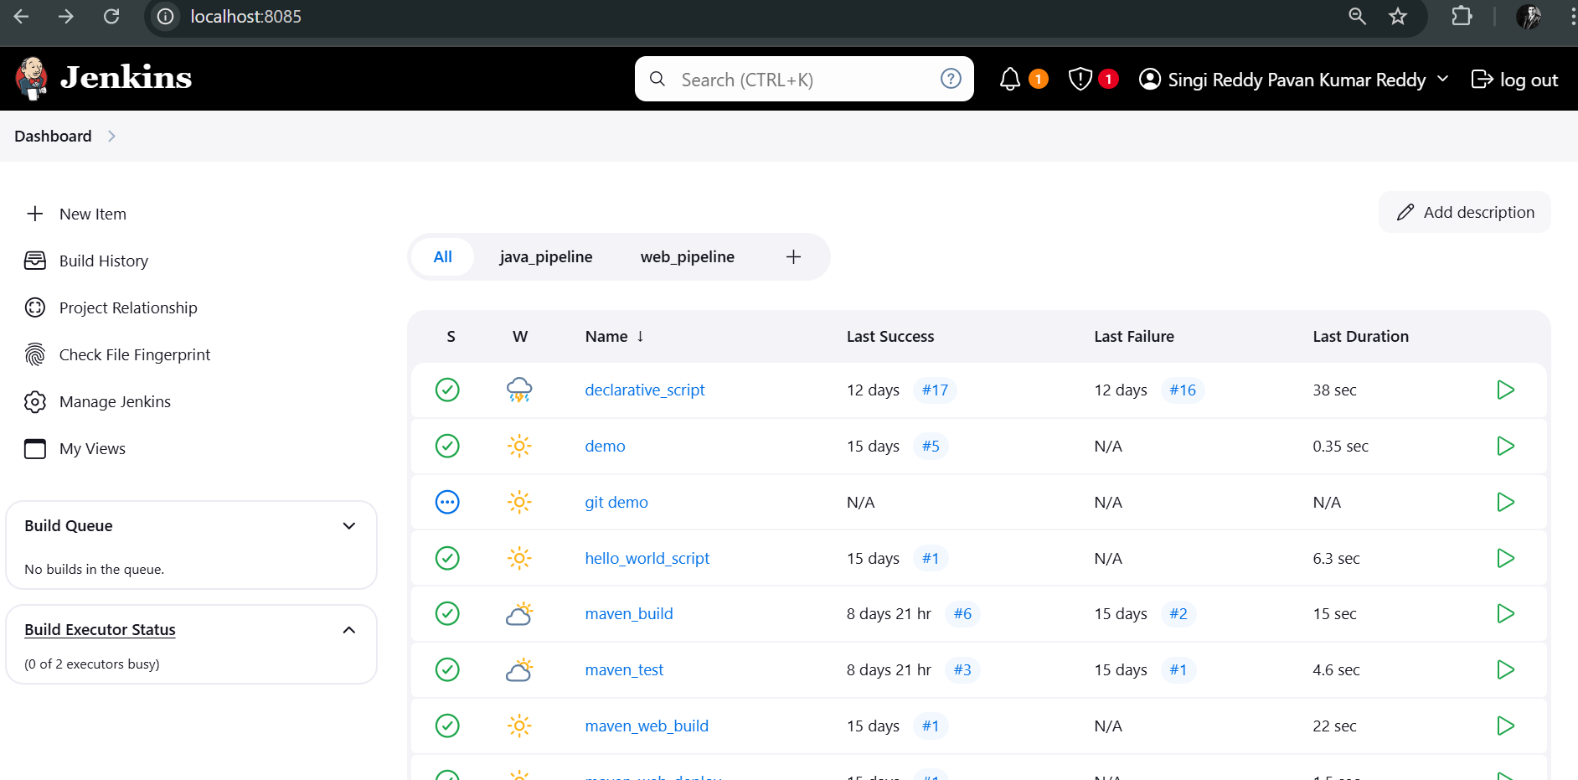

**Step 2: Create Freestyle Project (e.g., Pipeline Script)**

Enter project name (e.g., Pipeline Script)

Click "OK"

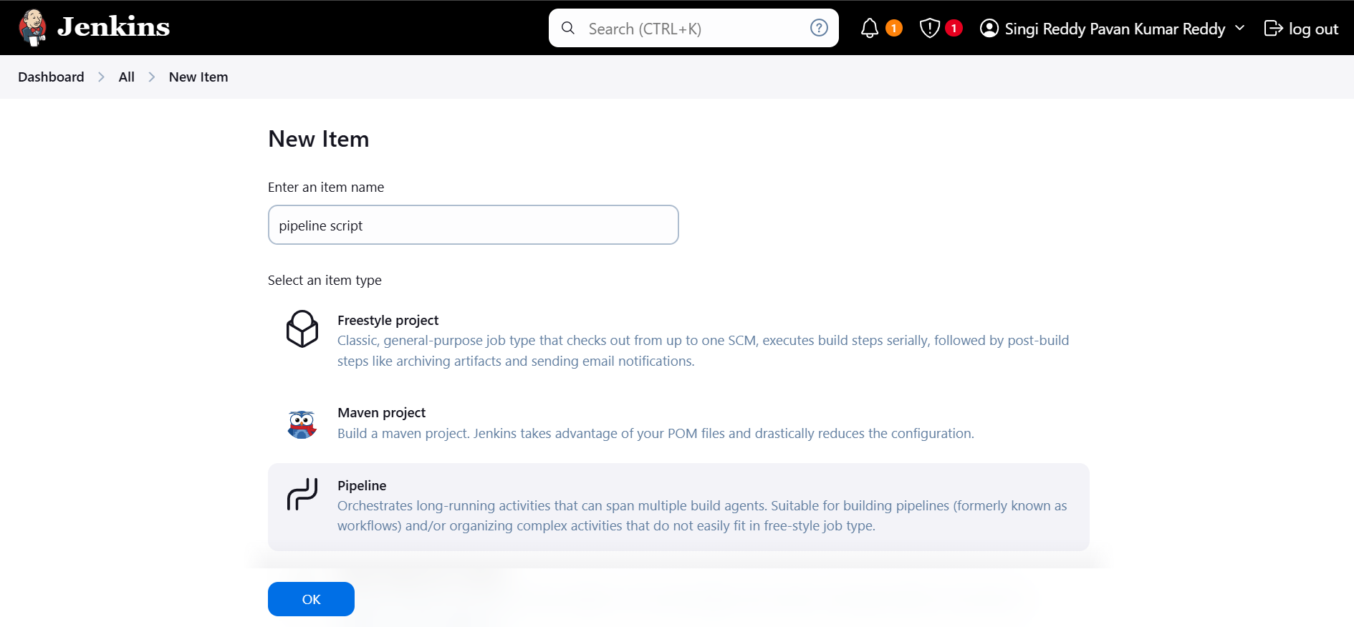

**Step 3: Advance project option:**

Choose pipeline script and copy the below code and paste it.

pipeline {

agent any

tools{

maven 'MAVEN-HOME'

}

stages {

stage('git repo & clean') {

steps {

//bat "rmdir /s /q mavenjava"

bat "git clone provide your github link"

bat "mvn clean -f mavenjava"

}

}

stage('install') {

steps {

bat "mvn install -f mavenjava" #project name#

}

}

stage('test') {

steps {

bat "mvn test -f mavenjava"

}

}

stage('package') {

steps {

bat "mvn package -f mavenjava"

}

}

}

}

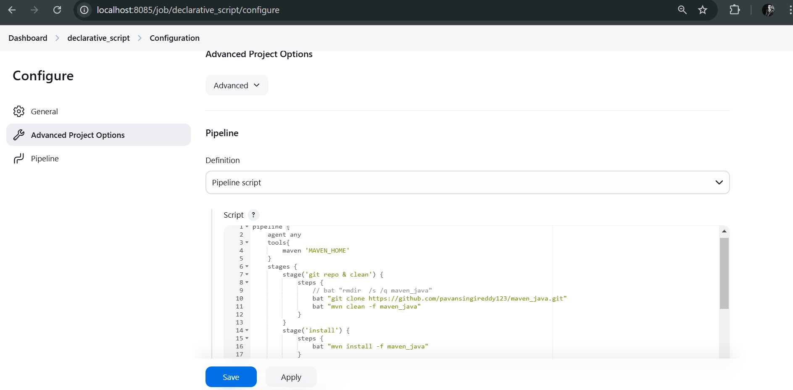

**Step 4:** click Save and Apply and Run the code



**Installation Of Docker for Windows**

**Download Docker for Windows**

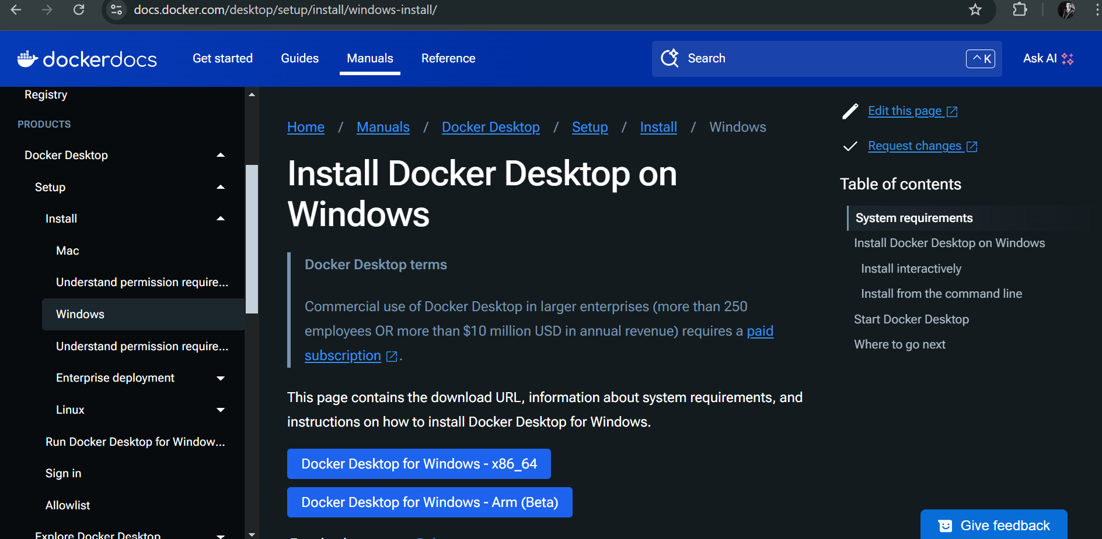

**Download Docker for Windows**

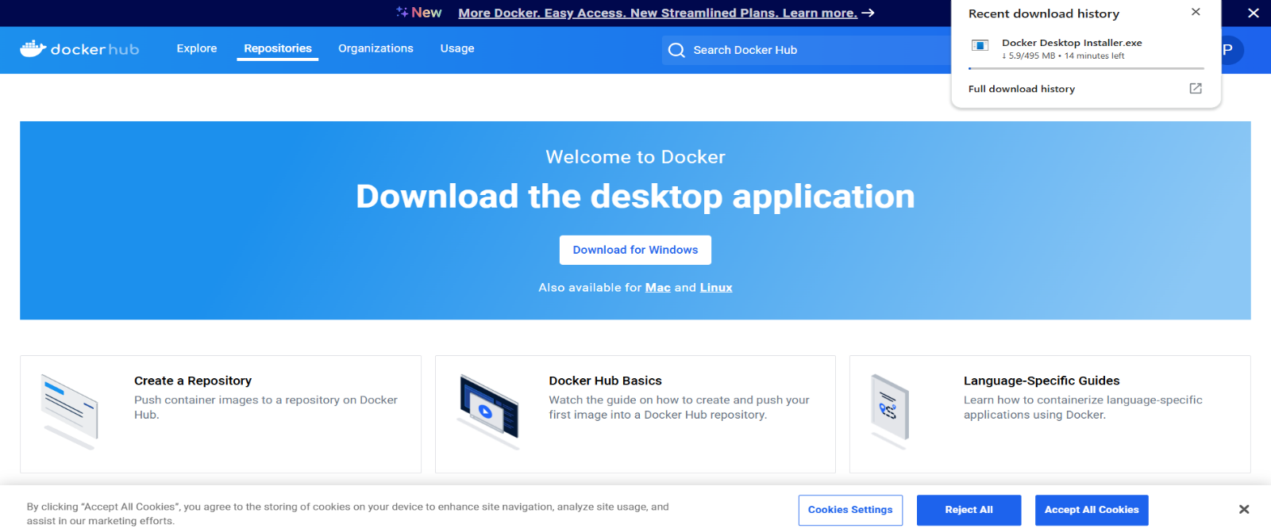

**Accept the license -> click Accept**



**The local Docker Hub is created**

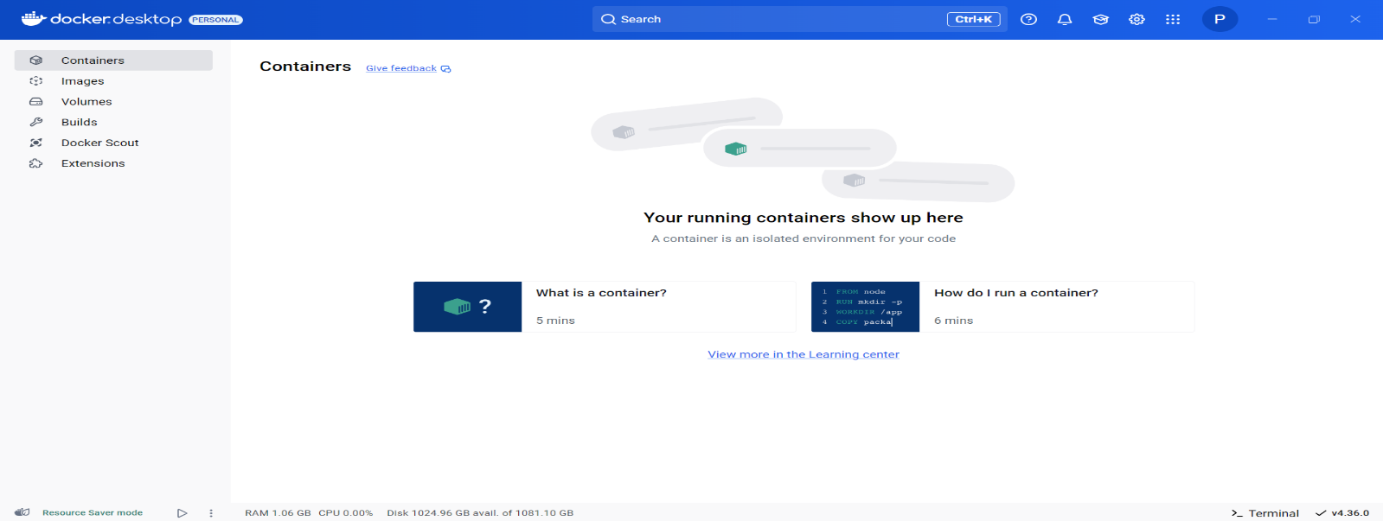

**Open Windows PowerShell as shown from Start**

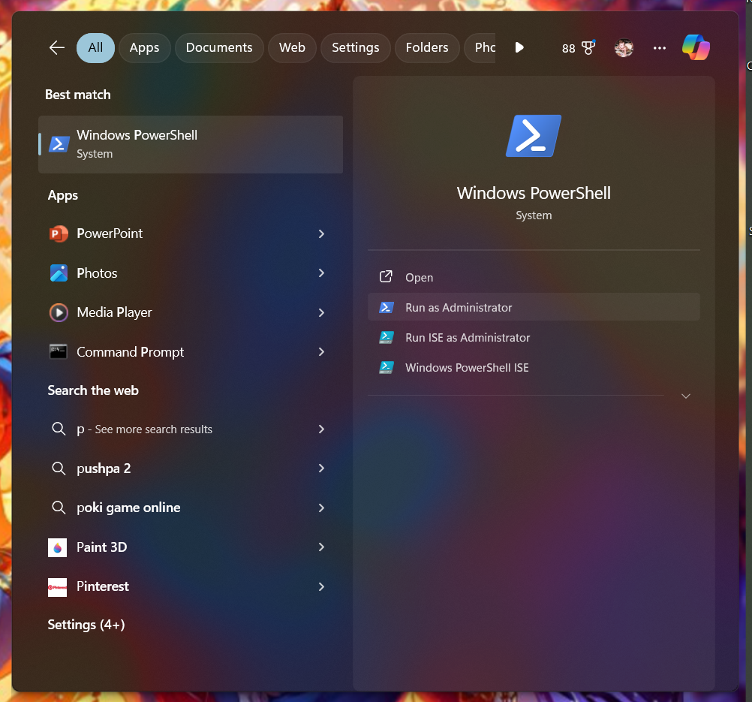

**Type the following command, to set WSL as default version**

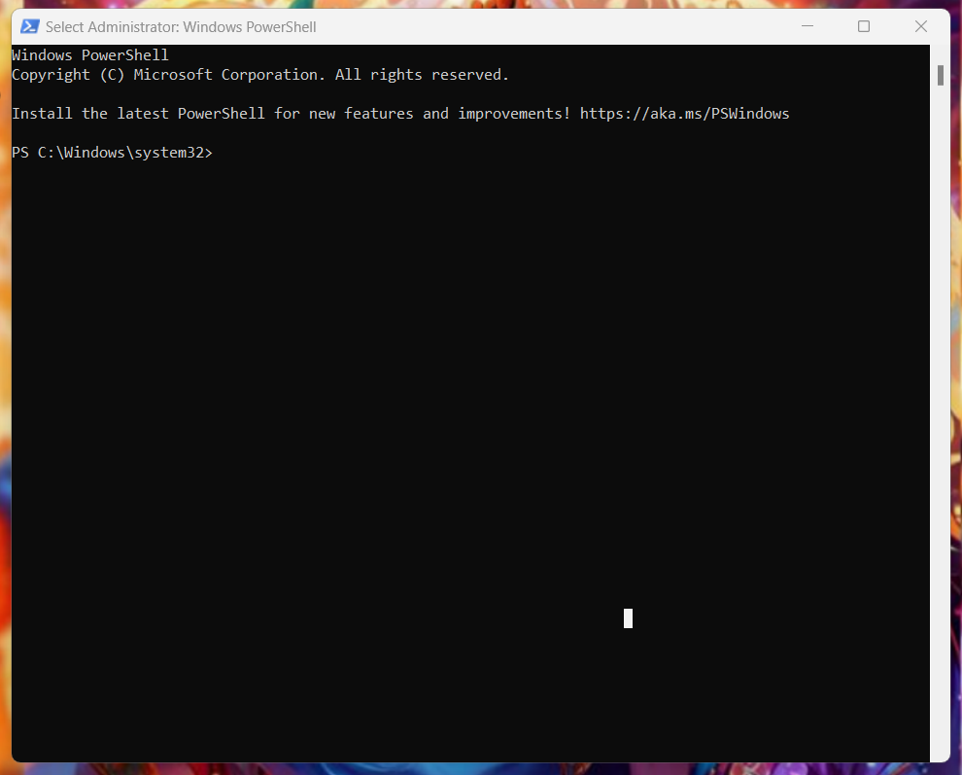

**Click on hub.docker.com and signup as shown**

**Sign In into Docker Hub**

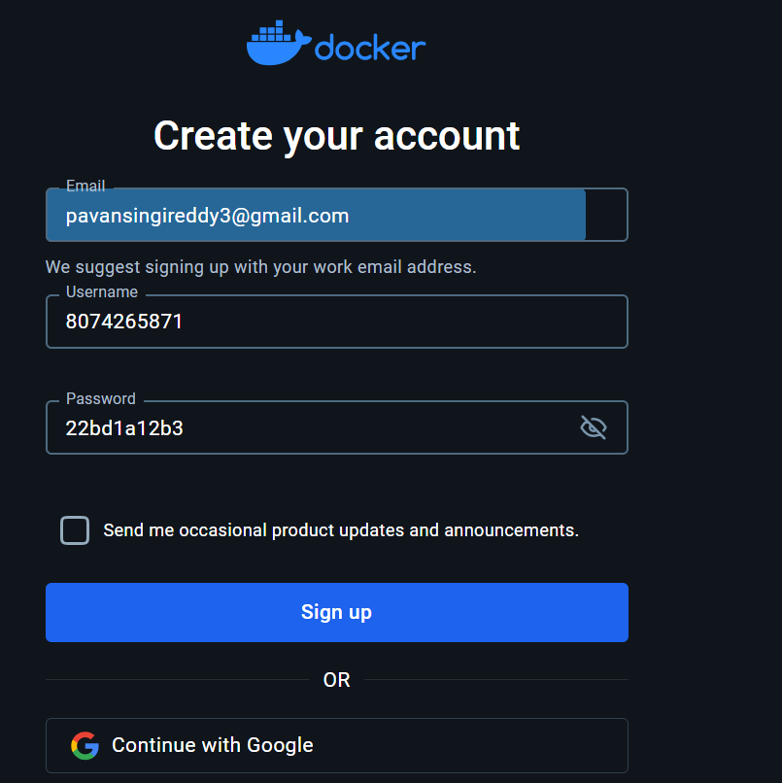

**Understanding Docker and Redis**

**What is Docker?**

Docker is a tool that makes running applications easy by packaging everything (code, libraries,

tools) into containers.

• Containers are like lightweight virtual machines but more efficient because they share

the host’s system resources.

What is Redis?

Redis (Remote Dictionary Server) is:

• A super-fast database that stores data in memory (not on a disk).

• Commonly used for:

o Caching: Storing temporary data for quick access.

o Real-time applications: Like live chat, analytics, or leaderboards.

o Data structures: Redis supports lists, hashes, sets, and more.

Example:

• Save data: Use the key "name" and the value "Alice".

• Retrieve data: Ask Redis for "name", and it will give you "Alice" instantly.

**Setting Up Docker**

**Step 1: Choose the Right Terminal**

• Windows: Use Git Bash or PowerShell (Git Bash is preferred for Docker commands).

• Mac/Linux/Ubuntu: Use the built-in Terminal.

**Step 2: Verify Docker Installation**

Run this command to check if Docker is installed:

**docker --version**

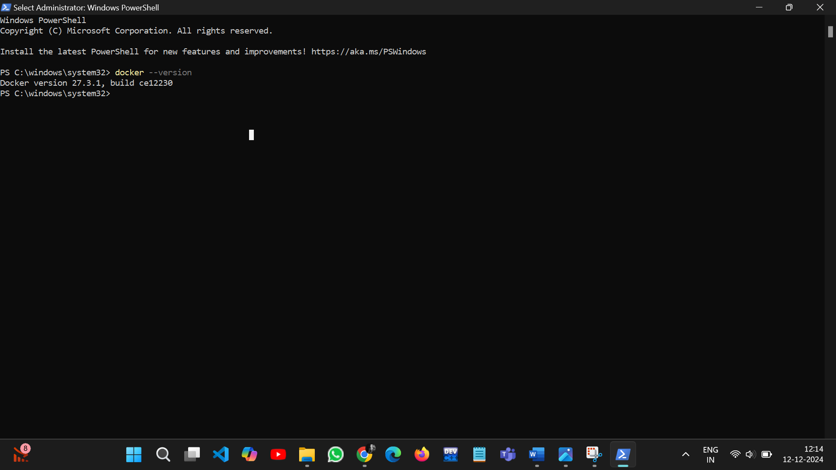

**What It Does:**

• Displays the installed Docker version to ensure everything is ready.

**Docker CLI Commands with hello-world**

Why Use hello-world?

The hello-world image is a basic test to ensure Docker is working correctly.

Step 1: Pull the hello-world Image

**Command:**

**docker pull hello-world**

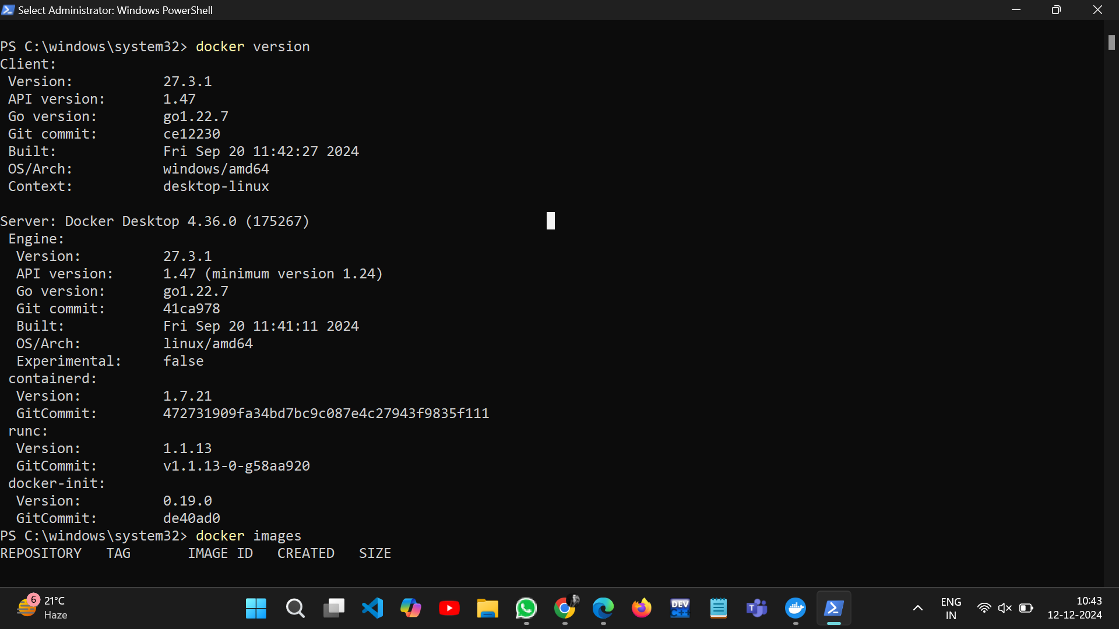

What It Does:

• Downloads the hello-world image from Docker Hub (Docker’s app store).

**Where to Run:**

• Open your terminal (Git Bash for Windows or Terminal for Mac/Linux).

• Run the command from any folder.

**Step 2: Run the hello-world Image**

**Command:**

**docker run hello-world**

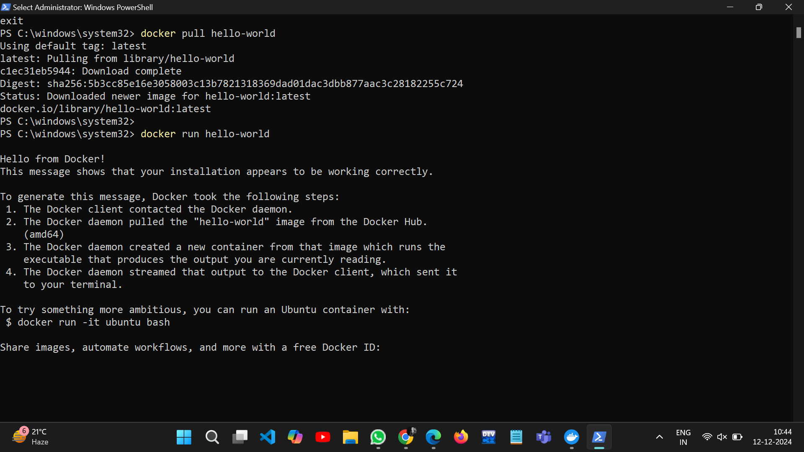

**What It Does:**

• Creates and runs a container from the hello-world image.

• Displays a message to confirm that Docker is installed and working.

**Output Example:**

Hello from Docker!

This message shows that your installation appears to be working

correctly.

**Step 3: View All Containers**

**Command:**

**docker ps -a**

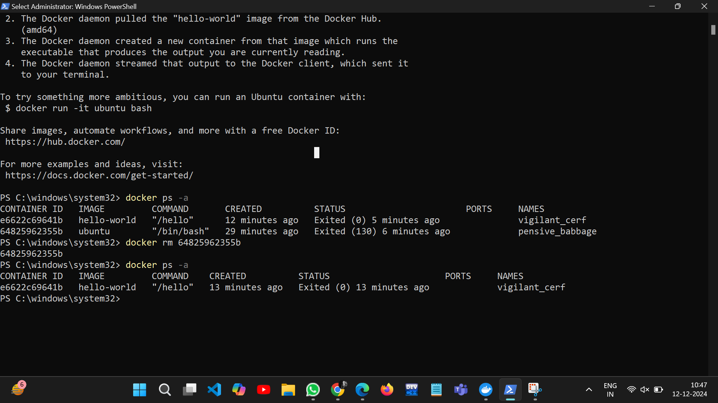

**What It Does:**

• Lists all containers (running and stopped).

• The hello-world container will show as "Exited" because it stops after displaying

the message.

**Step 4: Remove the hello-world Container**

**Command:**

**docker rm [container-id]**



**What It Does:**

• Deletes the container to free up space.

• Replace [container-id] with the actual ID from docker ps -a.

**Step 5: Remove the hello-world Image**

**Command:**

**docker rmi hello-world**



**What It Does:**

• Deletes the hello-world image if you no longer need it.

Docker CLI Commands with redis

**Why Use redis?**

Redis is a powerful, real-world example of a service often run using Docker.

**Step 1: Pull the redis Image**

**Command:**

**docker pull redis**

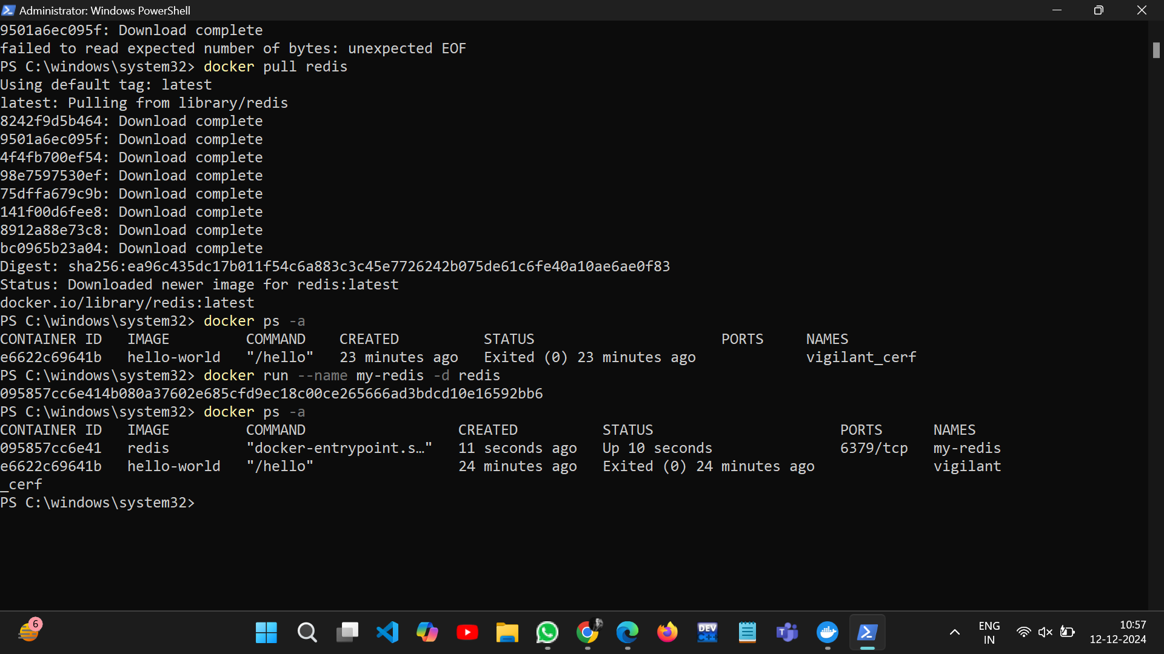

**What It Does:**

• Downloads the official redis image from Docker Hub to your system.

**Step 2: Run a Redis Container**

**Command:**

**docker run --name my-redis -d redis**

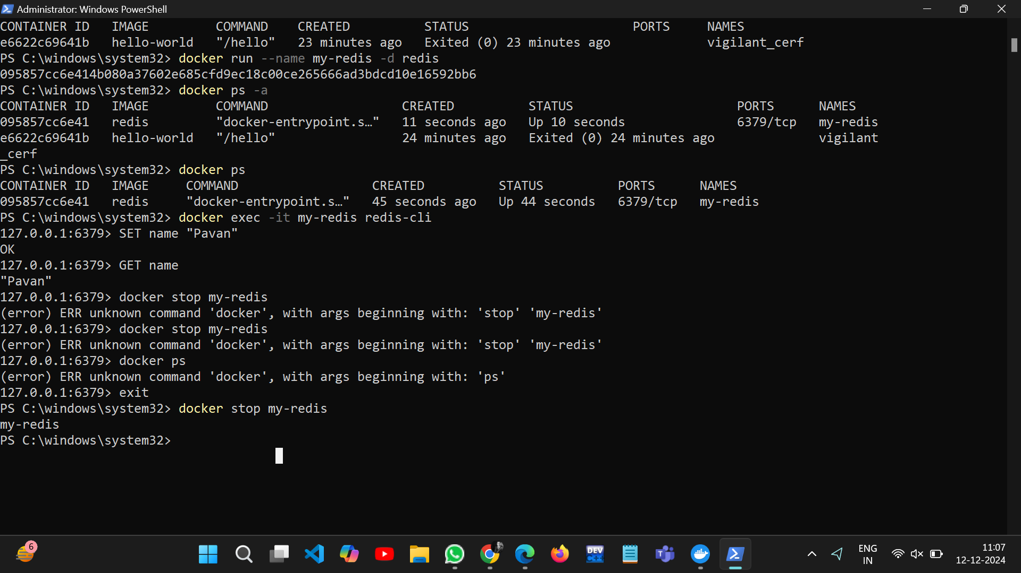

**What It Does:**

• Creates and starts a container named my-redis from the redis image.

• The -d flag runs the container in the background.

**Step 3: Check Running Containers**

**Command:**

**docker ps**



**What It Does:**

• Lists all running containers.

• You should see the Redis container (my-redis) in the list.

**Step 4: Access Redis**

**Command:**

**docker exec -it my-redis redis-cli**

**or**

**winpty docker exec -it myredis redis-cli**

**What It Does:**

• Opens the Redis command-line tool (redis-cli) inside the container.

• You can now send commands directly to the Redis server.

• winpty: This command makes Git Bash handle the terminal interaction correctly,

allowing you to run commands that require user input.

• docker exec -it myredis redis-cli: This runs the Redis command-line interface (redis

cli) inside the running myredis container.

**Example Redis Commands:**

**127.0.0.1:6379> SET name "Alice"**

**OK**

**127.0.0.1:6379> GET name**

**"Alice"**



**Step 5: Stop the Redis Container**

**Command:**

**docker stop my-redis**

**What It Does:**

• Stops the Redis container but doesn’t delete it.

**Step 6: Restart the Redis Container**

**Command:**

**docker start my-redis**

**What It Does:**

• Restarts the stopped container.

**• Command:**

**docker stop my-redis**